Fish of the James River

Directions: Research these 4 commons fish found in the James River. The White Perch has been completed for you. Here are some websites to help you.

Fish Resources: Weblinks form the Chesapeake Bay Program

https://www.chesapeakebay.net/S=0/fieldguide/critter/white_perch
https://www.chesapeakebay.net/S=0/fieldguide/critter/blue_catfish
https://www.chesapeakebay.net/discover/field-guide/entry/hogchoker
https://www.chesapeakebay.net/discover/field-guide/entry/smallmouth_bass

Objective: Students will be able to learn about 4 common fish species found in the James River. By learning about these fish students will be able to understand different characteristics and traits that each species possesses.

Characteristics | White Perch  Morone Americana | Blue Catfish  Ictalurus furcatus
Picture | 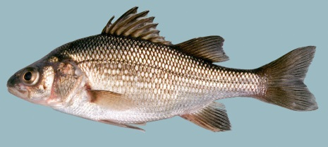
Physical Characteristic  What it looks like? | White perch grow seven to ten inches in length. They rarely weigh more than one pound. They have a silvery, greenish-gray body with faint lines on the sides. Whitish belly
Native or Non-Native | Native to James River
Mouth Position | Middle of body
Defensive Adaptation | Swim in schools for protection, Spines on its Dorsel Fin help protect from preditors
Diet  Herbivore, Omnivore, Carnivore? | Carnivore, Feeds on small fish, insects, detritus, and fish eggs and larvae

Characteristics | Hog Choker | Smallmouth Bass
Picture

Physical Characteristic
What it looks like?

Native or Non-Native

Mouth Position

Defensive Adaptation?
Diet
Herbivore, Omnivore, Carnivore

Conclusion: Questions
- Which of the four fish species is non-native and some say invasive species to the James River? What are two reasons we should keep invasive species out of the James River?
- By understanding the positioning of the fish’s mouth you can determine where it lives mostly in the James River? Which two fish typically live on the bottom of the river?
Who am I activity? By reading the brief description you should be able to guess which of the 4 species is being described?
- Who am I? I am a fish that is typically found on the bottom of the river. I was imported from the Mississippi River and have the ability to reproduce in large numbers of the James River.
- Who am I? I am a fish that doesn’t typically get that large. I often swim with many other fish in a school. I eat small fish, fish eggs, and insects.

Make your own “Who am I activity”? Using the information you collected write information about the Smallmouth Bass?

