JRA Video worksheet (Watershed, Food Chains, and Photosynthesis).
- Label the six states found in the Chesapeake Bay water shed. (Virginia, New York, Delaware, Pennsylvania, West Virginia, Maryland) 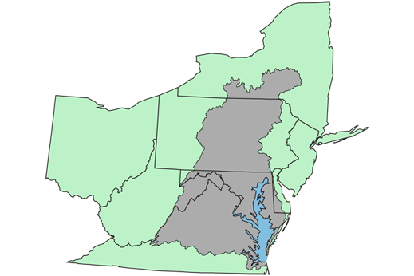

- List the 5 main rivers Captain Aaron mentions that impacts the Chesapeake Bay.

- In your own words, how do you define a food chain?

- Can you create another food chain with other Virginia species? Please create a 4 step food chain?

- In order for producers or plants to be the base of the food chain they must be able to make their own food. What is the formula for plants to make their own food?

___________ + ___________ + _____________ _______________ + ________________
- In the food chain below, what would happen if all the White Perch were removed?

Algae Minnow White Perch - Bald Eagle

