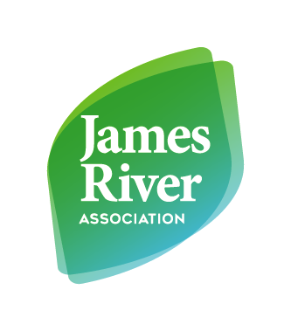

Benefits of a Wetland/Wetland in a Bottle
Objective: Students will investigate why wetlands are so important by learning about 3 major benefits. Students will create their wetland in a bottle to see how wetlands work.
Wetlands provide 3 major benefits:
1.) Filter out pollution from water (Nature’s Kidneys)
2.) Great habitat for fish, waterfowl, and wildlife
3.) Prevent flooding (Acts like a sponge to soak up excess water)
Directions: Students will build a wetland in a bottle with the supplies shown below. Students will place large rocks in the soda bottle first, small rocks second, sand in third and dirt (wet dirt) in last. Have someone hold the students wetland in a bottle. Make sure to place the clean jar under the wetland in a bottle. Now pour the dirty water into the top of your wetland.
Students will need:
- 1 bottle (2 litter Pepsi or Coke)
- 2 jars (1 clean, 1 with dirty water) (Peanut Butter jars work great)
- Large rocks
- Small rocks
- Dirt
- Sand
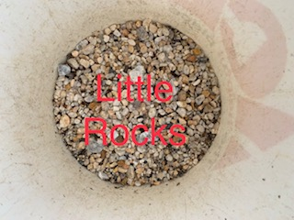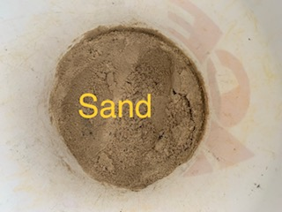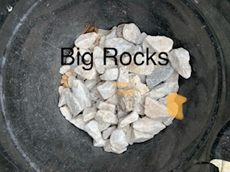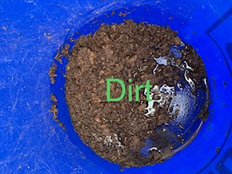
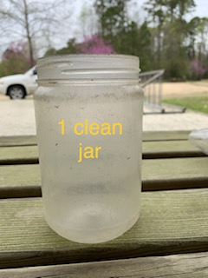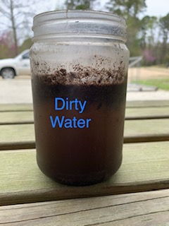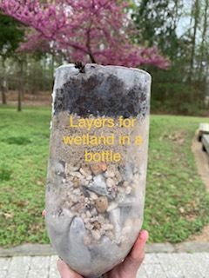
Questions to ask after building your wetland in a bottle.
- What did you notice?
- Is the water coming out cleaner?
- Why do you think the Coke/Pepsi bottle has 4 different layers? Is there a reason we have the large rocks on the bottom?
- After completing this project do you feel like wetlands are important? Why?
- What are the 3 major benefits of a wetland?
Conclusion: This lesson allows students to have a hands-on activity while learning about the benefits of wetlands. When pouring the water into the bottle you will notice that the dirt starts to absorb the water. The wetland in a bottle starts to filter out pollution until the water eventually becomes clearer.

Extra:
1.) Make your “polluted” water extra dirty. How many times did you have to run the water through the wetland in a bottle for it to be clear?
2.) Mix up the order of the layers in the bottle. Did you see a difference? What happened that was different from the correct order?

Great Resources:
https://www.epa.gov/wetlands/why-are-wetlands-important
https://www.nrcs.usda.gov/wps/portal/nrcs/main/national/water/wetlands/

